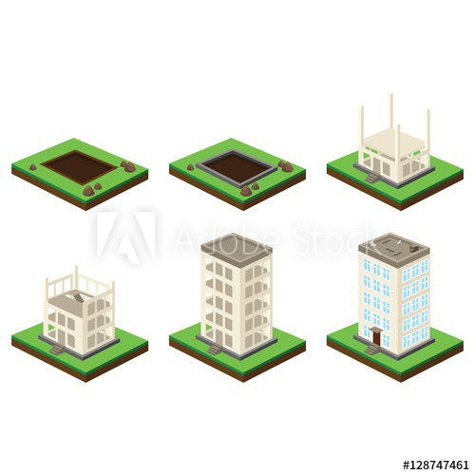

## CREATING A CONCEPT AND DESIGN

## OBTAINING BUILDING PERMITS

## CLEARING AND EXCAVATING THE LAND

## POURING THE FOUNDATION

## COMPLETING THE FRAMING

## DOING ROUGH ELECTRICAL AND PLUMBING

## INSTALLING THE ROOF

## TAKING CARE OF HEATING AND COOLING NEEDS

## COMPLETING THE INTERIOR

## FINISHING UP

## 2. [Stages of tunnel construction process isometric 2x2 icons set isolated on colorful backgrounds 3d vector illustration](https://thumbs.dreamstime.com/z/tunnel-construction-set-stages-tunnel-construction-process-isometric-icons-set-isolated-colorful-backgrounds-d-vector-101089571.jpg)Tunnel Construction 2x2 Set5 stages of home improvements[You are likely to encounter five distinct stages of home improvement: planning, budgeting, demolition, construction, and cleanup. With the choices you make at each stage, you can keep your project on track, on time, and on budget.](https://thumbs.dreamstime.com/z/stages-home-improvements-you-likely-to-encounter-five-distinct-improvement-planning-budgeting-demolition-construction-57925737.jpg)